G.C.C.E.E.I.  est. 1974 | Grand Council of the Crees (Eeyou/Eenou Istchee)  Grand Conseil des Cris (Eeyou/Eenou Istchee)  ᐄᓅ/ᐄᔨᔫ ᒋᔐᐅᒋᒫᐤ  CREE NATION GOVERNMENT  GOVERNEMENT DE LA NATION CRIE  Capital Works and Services Department  700 de la Gauchetière, Suite 1600  Montréal (Québec) H3B 5M2  Tel: (514) 861-5837 Fax: (514) 395-9099 www.cngov.ca | 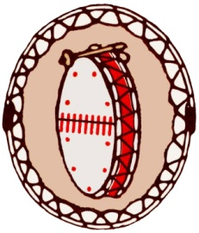  C.N.G.  G.N.C.  est. 1978

Addendum #1
Fire department Self Contained Breathing Apperatus
Tender #2019-T5
[June 19, 2019]

The addendum is for the modification to the tender: instructions to item 9 it currently states.

- SCBA AIR CYLINDRS :

The SCBA cylinders be 5.5 and be of carbon fiber and be of 4500psi (60 minutes)

Should read :
- SCBA AIR CYLINDRS :

The SCBA cylinders be of carbon fiber and be of 4500psi (60 minutes)

