Regional Parenting Conference; Highlights
CNG Newsletter

As background information would like to inform you of who we are as a Cree Regional Maamuu Uhpichinaausuutaau Committee. We are an early childhood regional committee in Eeyou Istchee. This regional committee has many partners from within Eeyou Istchee, who work directly or indirectly with children aged 0-5 years of age. We also have rotating seats for our Elders who are the visionaries and our greatest advisors on early childhood. The mission of this regional committee is to ensure that early childhood takes priority in Eeyou Istchee and ensuring that all children are provided with a strong foundation in order to develop to their best potential.
Our Vision: All Cree families blossom with happy and healthy children based on the teachings of our ancestors accordingly to the natural order as directed by our creator.
Goal: Unite to make Maamuu Uhpichinaausuutaau (Early Childhood) a priority in Eeyou Istchee.
Our Main Objectives:
- To make the early childhood a priority at the Regional and Local level
- To have better integrated services locally for the children and parents
- To support the communities so every baby is welcomed and supported (rites of passage, traditional teachings)
- To support the overall development of children aged 5 and under in all spheres of their development (spiritual, physical, mental, emotional/relational), in order that each child be given every chance to a good start in life.

One of the goals of our regional committee, which was expressed by one of our elders, was on childrearing in Cree society and how it has evolved over time, so we thought it would be beneficial to host a regional Cree parenting forum in Eeyou Istchee. Therefore, we planned and finally hosted a Regional Cree Parenting Conference which was held on July 23-25, 2019 in Mistissini.

The goal of this conference was to invite parents from all communities in Eeyou Istchee to come and learn about parenting through culture and knowledge shared from our elders and guest speakers as well as from a team of professionals from various organizations. The conference covered teachings from the past and present, as well as where we would like to see the future of healthy Cree parenting.

We are very happy that we were able to have this conference for the parents, elders, facilitators and EVERYONE who contributed and committed their time to be part of Maamuu Uhpichinaausuutaau 1st Regional Conference for parents. We envision having something very similar like this down the road. The Feedback from participants were very inspiring. In the evaluation of the three days, we asked the participants to fill out a short two question “Feedback Form”. We categorized them by

- Learnings:
  - Participants learned how to make traditional pampers, baby powder, and baby net etc.
  - “Very encouraging to see how we are developing in sustaining our way of life” from participant
- Elders and Traditional Teachings
  - How elders never run out of traditional things
  - They are valuable and hear elders transfer of knowledge
- Traditional Practices (learning by observation)
  - Baby needs are met by Natural means” such as moss diapers & natural baby medicine
- Participants WOW moments from Conference
  - “kids bring joy to the conference by making their presence. Very talented dancers from participant
  - “loved the lateral violence workshop, more of it and the fashion show (models) GREAT!”
  - “I have learned a lot from this conference, a lot of knowledge especially when elders speak”.
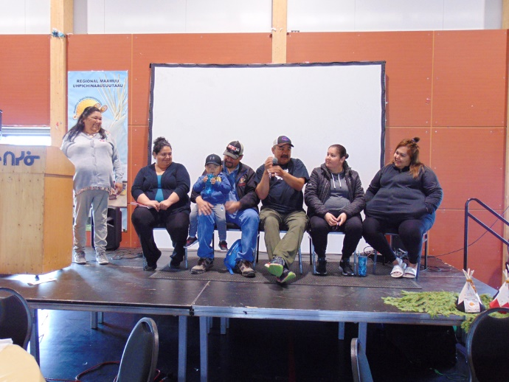
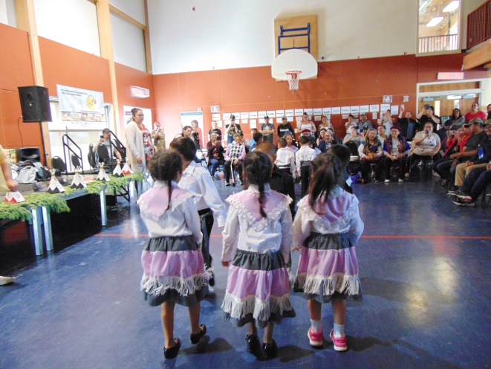
Here are some pictures of our Regional Parenting Conference.

